1. Creating a mapping project

This section explains how to set up a disturbance mapping project in QGIS. The setup process produces a QGIS project file and a project data package with the core layers needed for digitizing and validation.

A complete project typically includes the following components:
- a study area boundary layer;
- empty or existing linear and areal disturbance layers;
- two grids that intersect the study area: 2 x 2 km and 10 x 10 km;
- satellite imagery web services; and
- ancillary datasets to support interpretation and digitizing.

There are two pathways for creating a project file and data package. The appropriate pathway depends on whether your area of interest (AOI) falls inside or outside the boundary where compiled disturbance data are available, as shown in Figure 1. Both pathways include the following steps that are described in more detail below:
- Acquire or create an area of interest (AOI) map for your study region.
- Run the Geopackage Creator app and download disturbance and ancillary data for your AOI. If none are available, download the empty linear and areal disturbance layers from GitHub.
- Create a QGIS project file with your AOI, disturbance layers, ancillary layers, and web services.

Supporting material on GitHub

The disturbance mapping GitHub repository contains manuals, QGIS template files, and validation tools needed to support a mapping project. You can view the repository on GitHub. To download a local copy, select the green “Code” button and choose “Download ZIP”.

The repository is organized into the following folders and files:
- root folder: Includes a README file that describes the repository contents.
- manuals: Contains PDF versions of the manuals, including general_procedures.pdf and temporal_mapping_simplified.pdf.
- template: Includes sample files that you can for your project.
  - Two QGIS project files with satellite web services added:
    - digitizing_project1.qgz can be used if your AOI contains disturbances data that can be downloaded using the Geopackage Creator app.
    - digitizing_project2.qgz can be used if your AOI has no available disturbance data, in which case it will load the data_package.gpkg file, which contains empty linear and areal disturbance layers.
  - A geopackage file with empty linear and areal disturbance layers (data_package.gpkg) in case there is no disturbance data in your study area.
  - A list of disturbance types and industries (disturbance_types.csv).
- validation: Contains a Shiny app to assist in viewing mapping results, performing attribute validation, and editing attributes. It is best run from this link.

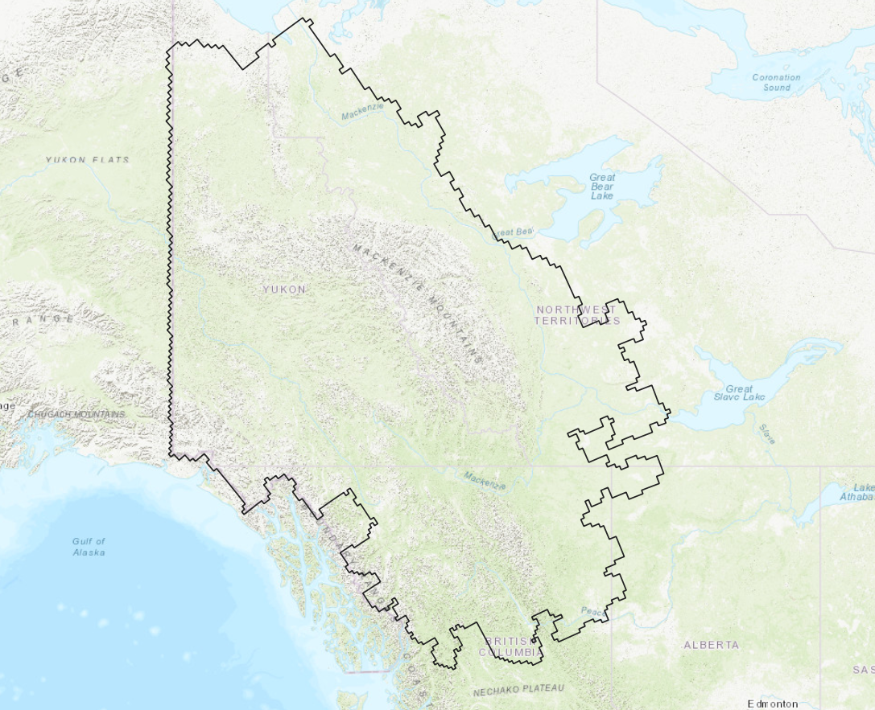
Figure 1. Boundary of datasets available withing the Geopackage Creator app. If your AOI is within this area, use Option 1 below to create your project data package, otherwise use Option 2.

1.1 Creating a data package

To start a disturbance mapping project, create a geopackage file that contains the layers needed for digitizing and review. The workflow depends on whether your area of interest (AOI) falls within the dataset boundary shown in Figure 1.

Option 1: AOI is within the Figure 1 boundary
- Prepare an AOI geopackage or shapefile. The AOI should contain one polygon in the coordinate reference system (CRS) you will use for digitizing, such as Yukon Albers Equal Area (EPSG:3578).
- Open the AOI in the GeoPackage Creator and select the required layers.
  - linear_disturbance and areal_disturbance
  - grid_2x2km and grid_10x10km
  - any available ancillary layers that may help with digitizing
- Save the AOI and selected layers in a geopackage named data_package.gpkg.
- Download digitizing_project1.qgz from the template directory on GitHub.
- Create a project directory on your computer for digitizing.
- Place digitizing_project1.qgz and data_package.gpkg in the project directory.
- Open digitizing_project1.qgz in QGIS and confirm that the disturbance datasets, ancillary datasets, and satellite imagery are available.
- Begin digitizing.

Option 2: AOI is outside the Figure 1 boundary
- Prepare an AOI geopackage or shapefile. The AOI should contain one polygon in the coordinate reference system (CRS) you will use for digitizing, such as Yukon Albers Equal Area (EPSG:3578).
- Download digitizing_project2.qgz and data_package.gpkg from the template directory on GitHub.
- Create a project directory on your computer for digitizing.
- Place digitizing_project2.qgz and data_package.gpkg in the project directory.
- Open data_package.gpkg in the Disturbance Validation app.
- Use the app to create the 2 x 2 km and 10 x 10 km grids.
- Save the new grids and all required layers in data_package.gpkg.
- Open digitizing_project2.qgz in QGIS and confirm that the disturbance datasets, ancillary datasets, and satellite imagery are available.
- Begin digitizing.

1.2 Data layers

1.2.1 Adding web services

1.3 Disturbance attributes

